Splunk Brute Force Detection Lab
Technical Deep Dive · sec-01
Project ID | Repository | Code version described | Last verified
sec-01 | splunk-bruteforce-detection-lab | soc_automation.py at c11e44c (main), identical on docs/portfolio-review | 2026-10-26
Labels. [Verified] read in the repo, history or screenshots · [Inferred] my reasoning from that evidence · [Recommended] a suggestion, not implemented.
Contents. 1 System Architecture · 2 Components and Dependencies · 3 API Integrations · 4 Authentication · 5 Data Flows · 6 Input and Output Structures · 7 Error Handling · 8 Logging and Monitoring · 9 Security Considerations · 10 Deployment Architecture · 11 Testing Methodology · 12 Troubleshooting · 13 Performance · 14 Future Engineering Improvements

1. System Architecture
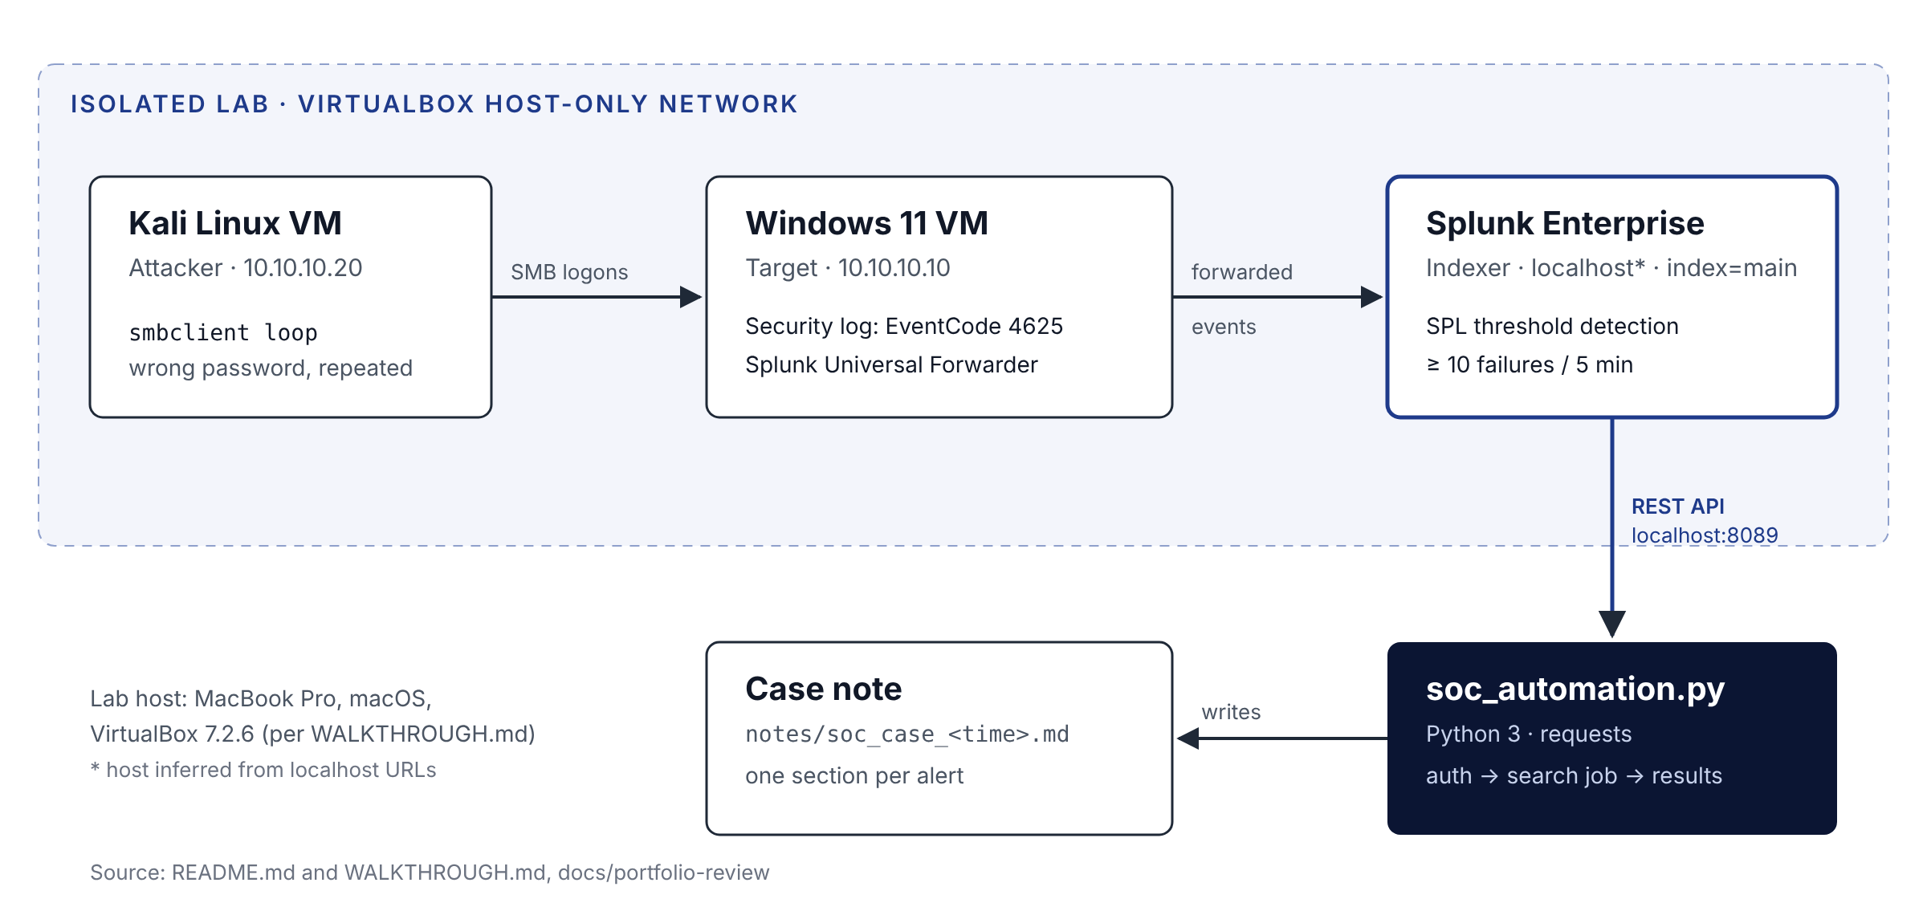
Lab architecture
[Verified] Four parts: an attacker VM (Kali, 10.10.10.20), a target VM (Windows 11, 10.10.10.10) running the Splunk Universal Forwarder, a Splunk Enterprise indexer, and a Python client. The VMs share a VirtualBox host-only network; each also has a NAT adapter for package installs.
[Inferred] Splunk Enterprise ran on the Mac host, since the Splunk web UI and the script both address it as localhost.

2. Components and Dependencies
Component | Version or setting | Source
VirtualBox | 7.2.6 | WALKTHROUGH.md
Host | MacBook Pro M5 Pro, macOS | WALKTHROUGH.md
Windows forwarder input | [WinEventLog://Security], disabled = 0, index = main | WALKTHROUGH.md
Splunk Enterprise | Version not recorded | Unverified
Python | 3 (minor version not recorded) | README.md
requests | >=2.31 | requirements.txt (docs branch)
urllib3 | Imported directly; installed with requests | soc_automation.py
smbclient | Kali package, version not recorded | WALKTHROUGH.md

3. API Integrations
[Verified] The script uses three Splunk REST endpoints on the management port, 8089:
Step | Method and endpoint | Key parameters | Returns
Authenticate | POST /services/auth/login | username, password, output_mode=json | sessionKey
Run search | POST /services/search/jobs | search, exec_mode=blocking, output_mode=json | sid
Fetch results | GET /services/search/jobs/{sid}/results | output_mode=json, count=0 | results array
Timeouts: 30 s for login and results, 120 s for the blocking search.
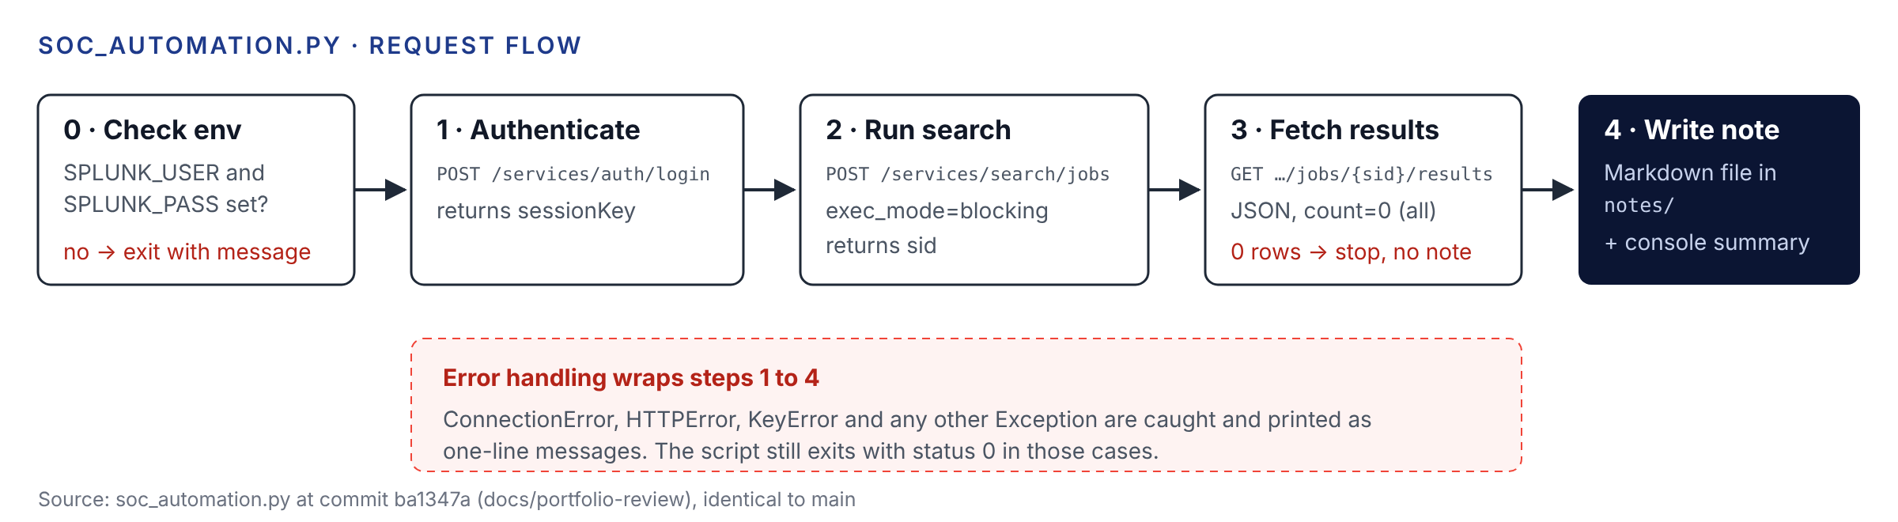
Script request flow

4. Authentication Mechanisms
[Verified] Username and password come only from the SPLUNK_USER and SPLUNK_PASS environment variables. If either is missing, the script stops before any network call. The login returns a session key, which is sent on later calls as Authorization: Splunk <sessionKey>.
[Verified] The first committed version (a7e36cb, 2026-04-01) fell back to admin and a placeholder password. The restored version (5c6dd51, 2026-10-11) removed those defaults.
[Recommended] For anything beyond a lab, use a Splunk authentication token for a least-privilege service account instead of a password and session key.

5. Data Flows
- [Verified] smbclient on Kali attempts SMB logons to //10.10.10.10 as administrator with a wrong password.
- [Verified] Windows writes Event ID 4625 (an account failed to log on) to the Security log.
- [Verified] The forwarder sends the events to Splunk as sourcetype=WinEventLog:Security in index=main.
- [Verified] The SPL search filters, buckets and counts the events; the script receives the result rows as JSON.
- [Verified] The script writes one Markdown note to notes/ and prints a summary.

6. Input and Output Structures
Detection input [Verified]: Windows 4625 events with the fields Account_Name, Source_Network_Address, Logon_Type, Failure_Reason, host, _time.
Search in the script [Verified]:
search index=main sourcetype="WinEventLog:Security" EventCode=4625
| where NOT (Source_Network_Address="127.0.0.1" OR Source_Network_Address="::1")
| bucket _time span=5m
| stats count as failed_logins
values(Logon_Type) as logon_types
values(Failure_Reason) as reasons
values(host) as host
by Account_Name, Source_Network_Address, _time
| where failed_logins >= 10
| eval severity=if(failed_logins >= 20, "High", "Medium")
| sort - failed_logins
| table _time Account_Name Source_Network_Address host failed_logins logon_types reasons severity
The saved search in queries/brute_force_detection.spl is the same up to the threshold, without the extra fields, and always sets severity to High.
Result row [Verified]: one row per account name, source address and five-minute bucket with at least 10 failures.
Output [Verified]: notes/soc_case_YYYYMMDD_HHMMSS.md with an alert count, then one section per alert: severity, account and source in the heading; time bucket, host, account, source IP, failed logins, logon types and reasons as bullets; and three fixed recommended actions.

7. Error Handling
[Verified] Behavior by case:
Case | What happens | Exit status
Credentials not set | Prints “Set SPLUNK_USER and SPLUNK_PASS…” | 1
Splunk unreachable | Prints “Could not connect to Splunk…” | 0
HTTP error (for example wrong password) | Prints the HTTP error | 0
Unexpected JSON shape | Prints the missing key | 0
Any other exception | Prints “Unexpected error” | 0
No rows above threshold | Prints “No alerts found…”, writes no file | 0
[Inferred] Because failures exit 0, a scheduler or CI job would treat a failed run as a success.

8. Logging and Monitoring
[Verified] No log file or logging framework; progress goes to standard output with [*], [+] and [!] prefixes. Splunk itself provides the monitoring layer for the lab. Generated notes are ignored by git (notes/ and soc_case_*.md).

9. Security Considerations
Item | State | Label
Attack traffic confined to host-only network | Documented in SECURITY.md and WALKTHROUGH.md | Verified
Credentials from environment only | Implemented | Verified
TLS verification disabled, warnings suppressed | Implemented for the self-signed lab certificate | Verified
.gitignore covers keys, .env, cloud credentials, Terraform state | Implemented | Verified
Screenshots show lab IPs and the administrator account | Lab-only values, documented as acceptable | Verified
Branch protection and secret scanning on GitHub | Recommended in README and SECURITY.md; actual repo settings not checked | Unverified

10. Deployment Architecture
[Verified] Nothing is deployed. Everything runs on one laptop: two VirtualBox VMs and a locally run Python script. The repository is the published artifact.

11. Testing Methodology
[Verified] Manual, evidence-based testing, recorded as screenshots. Results are as stated in WALKTHROUGH.md; I viewed screenshots 05 and 07 myself and they match.
Check | Evidence | Result
Target has static IP | Screenshot 01 | 10.10.10.10
Attacker reaches target | Screenshot 02 | 0% packet loss
Attack generates failures and lockout | Screenshot 03 | Lockout observed
Events ingested | Screenshot 04 | 81 failed logons from 10.10.10.20
Threshold detection | Screenshot 05 | 8 rows, all High
Log coverage | Screenshot 06 | 376 Security events, 4625 dominant
Script run and note | Screenshots 07 and 08 | 2 alerts written
[Verified] There are no automated tests and no .github workflows on either branch.

12. Troubleshooting Procedures
Symptom | Likely cause | First check
“Could not connect to Splunk” | Splunk not running or 8089 not reachable | Open https://localhost:8089 in a browser
HTTP 401 on login | Wrong credentials in the environment | echo $SPLUNK_USER; never echo the password
“No alerts found” | No 4625 events in the window, or below 10 per bucket | Run the SPL in Splunk Web with the same time range
Events missing in Splunk | Forwarder not sending | Check the forwarder service and inputs.conf on Windows
Duplicate alerts per bucket | Two account names per 4625 event | See Engineering Learning Guide, section 7
[Inferred] The REST search sets no time range, so Splunk applies its default. That may differ from the Splunk Web time picker, which used “Last 60 minutes” in screenshot 05.

13. Performance Considerations
[Inferred] Data volume is tiny (376 events in the coverage screenshot), so performance is not a concern in the lab. At production scale the unbounded time range and index=main search would be the first things to change: add earliest/latest, a dedicated index, and a scheduled saved search.

14. Future Engineering Improvements
All items below are [Recommended] and not implemented.
- Fix the double count by grouping on the target account only.
- Exit non-zero on failure.
- Make SPLUNK_HOST and TLS verification configurable through environment variables.
- Use a Splunk token for a least-privilege account.
- Set an explicit time range on the REST search.
- Add a correlation search for a 4624 success after the failures.
- Add unit tests with mocked Splunk responses and a CI workflow.
- Send the case note to a ticketing system or chat channel.

